Experiment:-18

Problem Statement:-
In many real-world applications such as log analysis, report generation, and glossary processing, it is often required to access the last few entries of a file and display them in reverse order. Bash scripting provides support for arrays, which can be effectively used to store file content and manipulate it programmatically.
The problem is to write a shell script that reads the last few lines of a glossary file, stores them in an array, and prints them in reverse order, demonstrating the use of arrays and reverse traversal in Bash scripting.

Aim:-Understanding virtual terminal, display manager, X client and window managers in linux

Procedure:-
Procedure A. Creating a Glossary File
1. Open the terminal.
2. Create a glossary file: nano glossary.txt

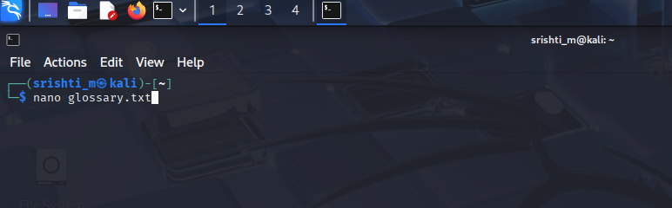

3. Enter sample content: Linux: Open-source operating system , Bash: Shell scripting language, Kernel: Core of operating system, File System: Structure for storing data , Networking: Communication between systems

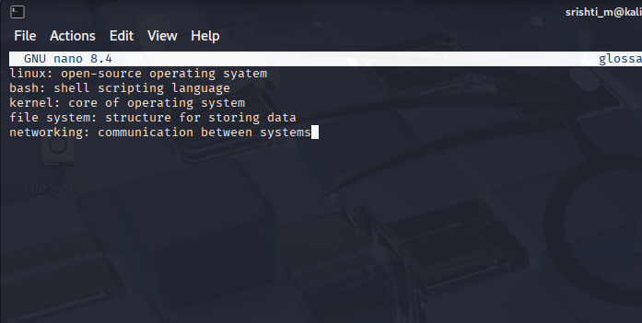
4. Save and exit the editor.
B. Writing the Shell Script
5. Create a script file:
nano reverse_glossary.sh
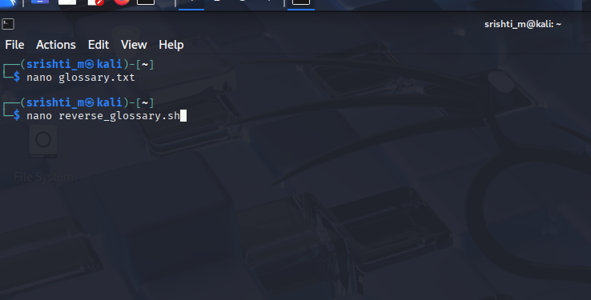

6. Enter the following script:
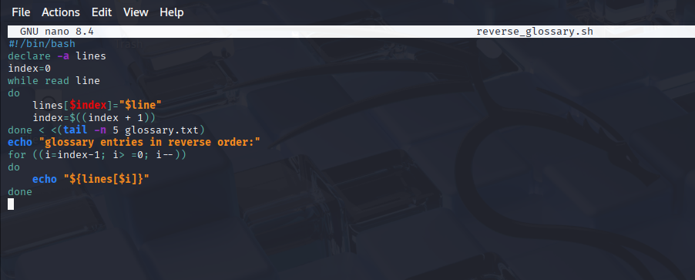
7. Save and exit the editor.
8. Make the script executable: chmod +x reverse_glossary.sh
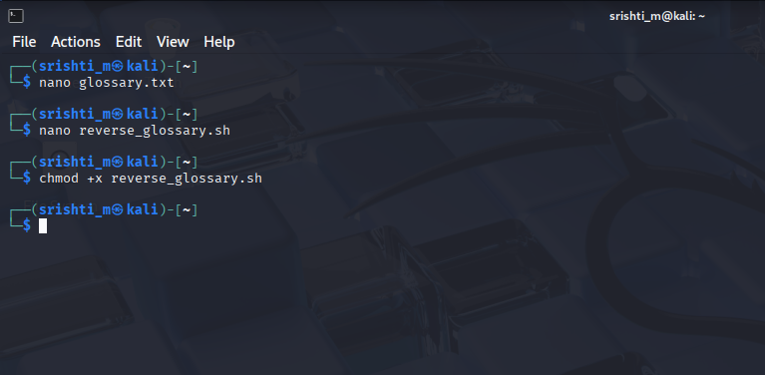
C. Executing the Script
9. Run the script: ./reverse_glossary.sh
